**----Steps to Install RAC and Oracle home on MDC cluster (Linux 7.9)**

1. **Create directories on all Nodes.:-**

[root@hrmdc1oel01 software]# cat rac.txt

groupadd -g 54421 oinstall

groupadd -g 54322 dba

groupadd -g 54323 oper

groupadd -g 54324 backupdba

groupadd -g 54325 dgdba

groupadd -g 54326 kmdba

groupadd -g 54327 asmdba

groupadd -g 54328 asmoper

groupadd -g 54329 asmadmin

groupadd -g 54330 racdba

/usr/sbin/useradd -u 54331 -g oinstall -G dba,asmdba,asmoper,asmadmin,backupdba,dgdba,kmdba,racdba grid

usermod -aG dba,asmdba,asmoper,asmadmin,racdba grid

mkdir -p /u02/app/19.3.0/grid

mkdir -p /u02/app/grid

mkdir -p /u02/app/oracle

chown -R grid:oinstall /u02

chown oracle:oinstall /u02/app/oracle

chmod -R 775 /u02/

[root@hrmdc1oel01 software]#

1. **Unzip GRID and Oracle software on NODE1 only:-**

**Unzip GRID home - As GRID user**

[grid@hrmdc1oel01 ~]$ cd /u02/app/19.3.0/grid

[grid@hrmdc1oel01 grid]$ unzip /u01/software/MDCRAC/LINUX.X64_193000_grid_home.zip .

**Unzip ORACLE home – as oracle user**

[oracle@hrmdc1oel01 ~]$ cd /u02/app/oracle/product/19.3.0/db_1/

[oracle@hrmdc1oel01 db_1]$ unzip /u01/software/MDCRAC/LINUX.X64_193000_db_home.zip .

1. **Run Cluvfy on node 1**

./runcluvfy.sh stage -pre crsinst -n hrmdc1oel01.washdc.state.sbu,hrmdc1oel02.washdc.state.sbu,hrmdc1oel03.washdc.state.sbu -r 19 > /tmp/runcluvfy_pre_hrmdc1.txt

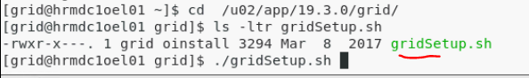

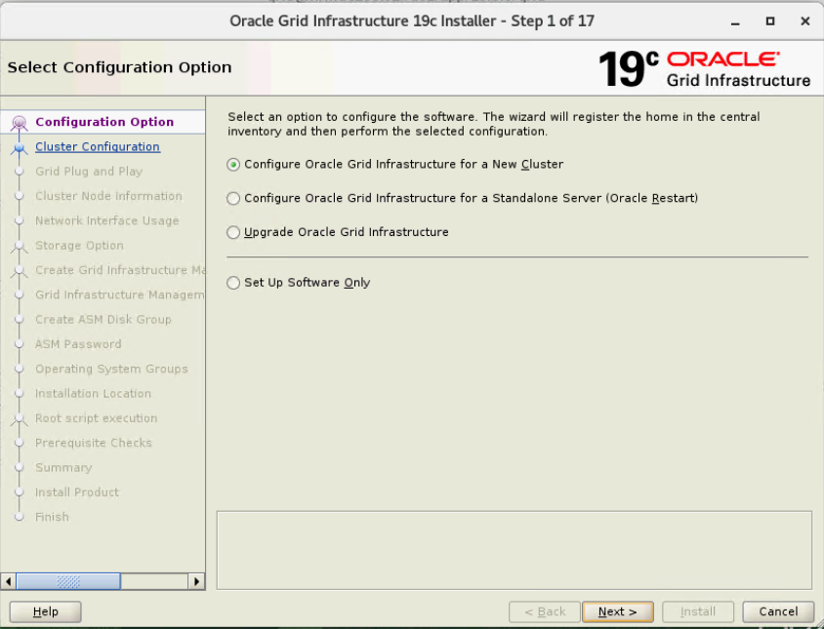

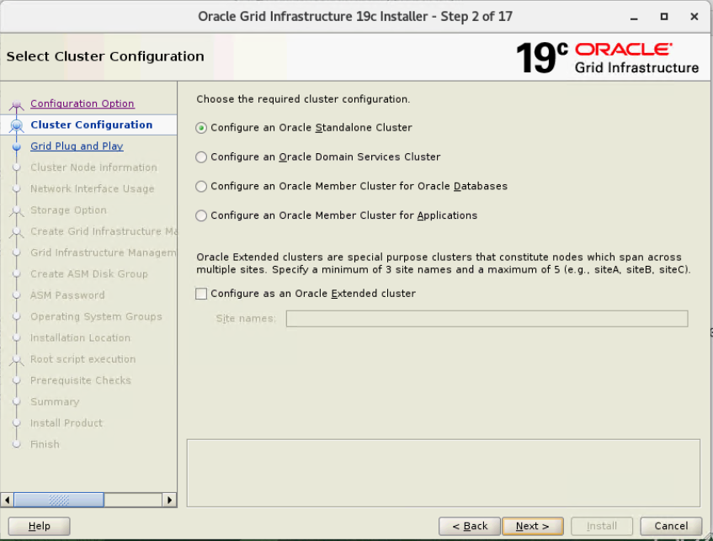

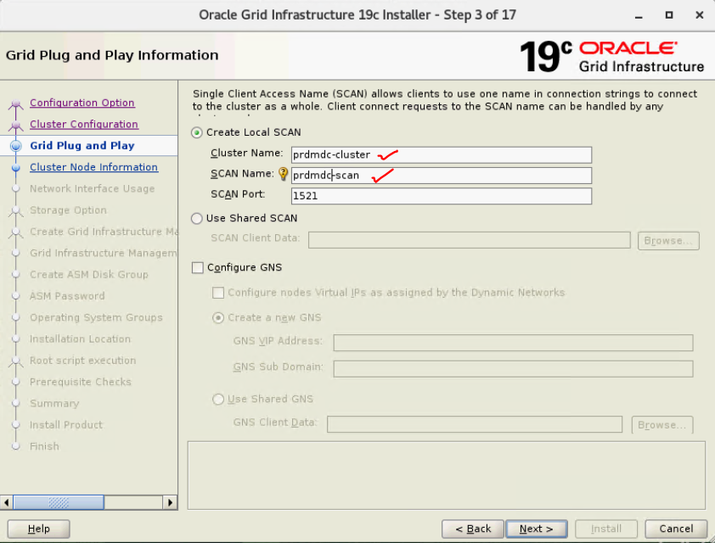

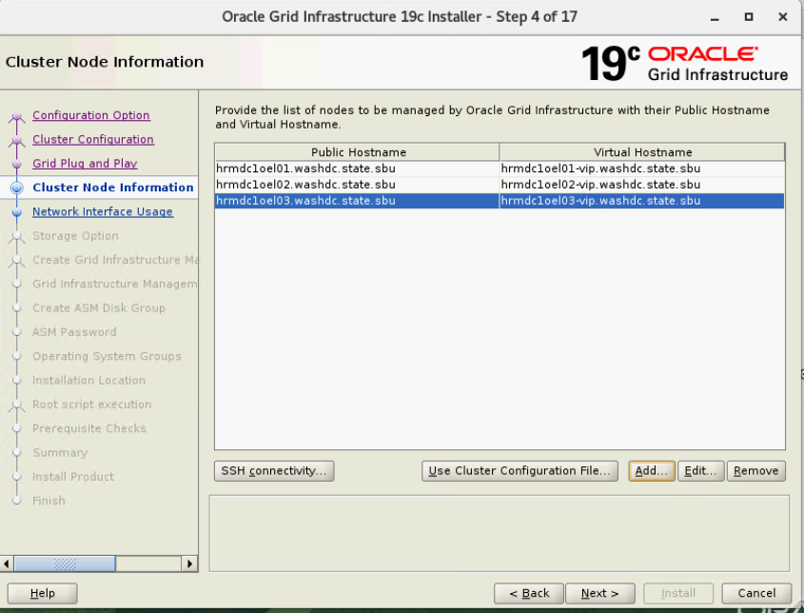

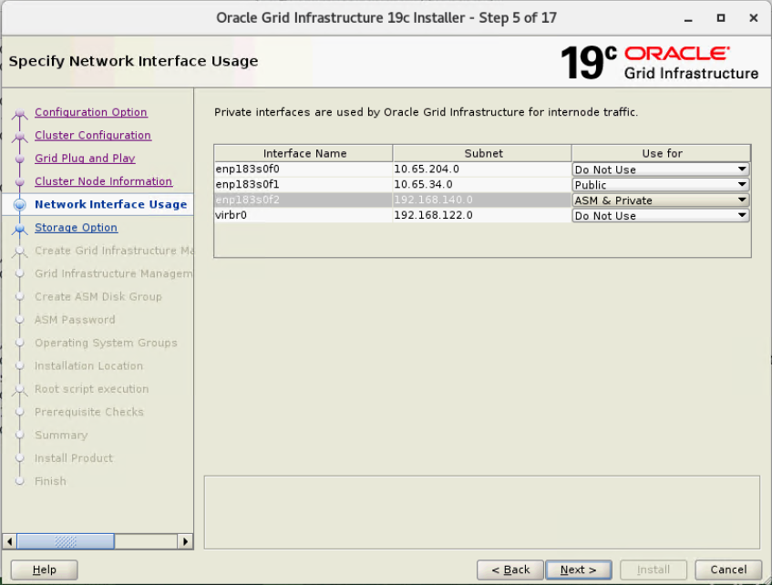

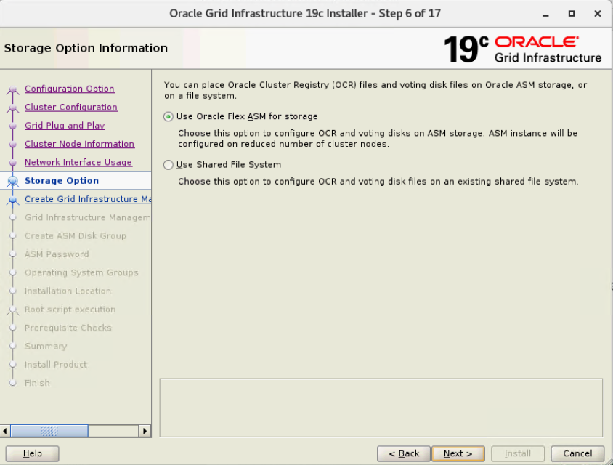

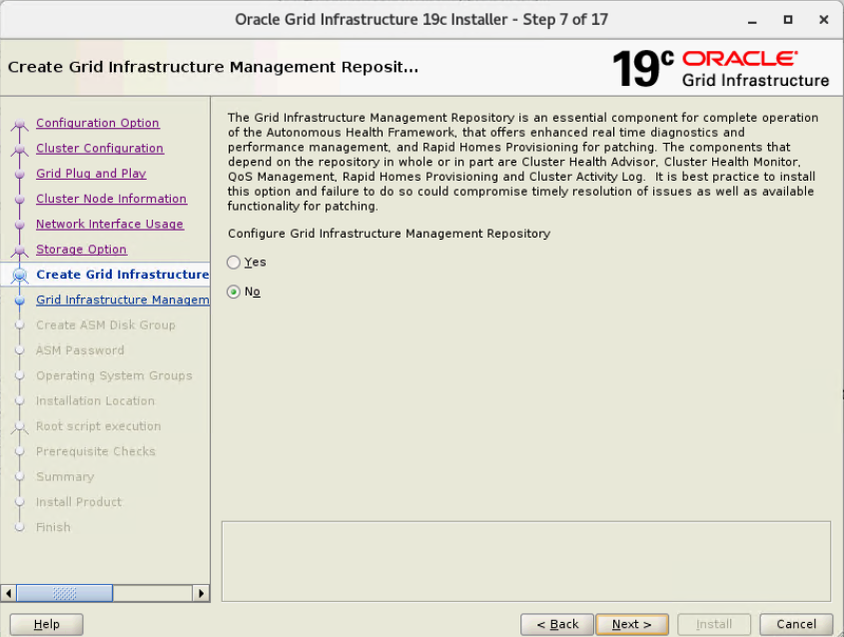

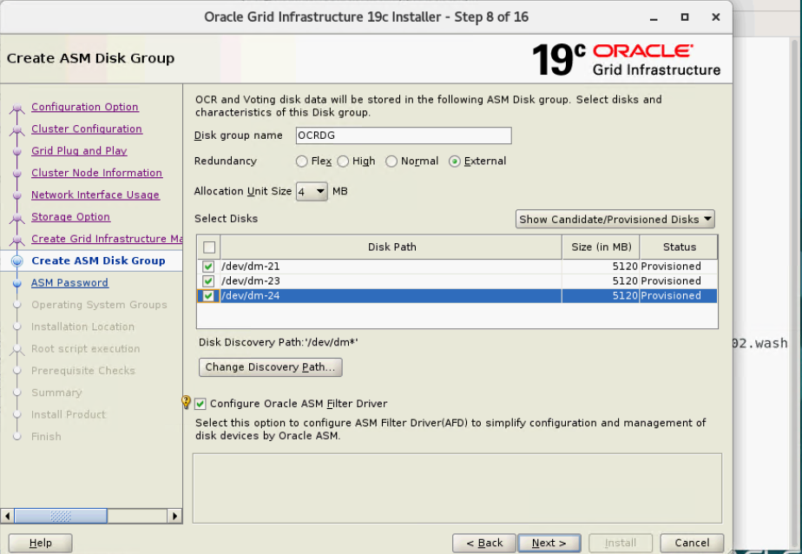

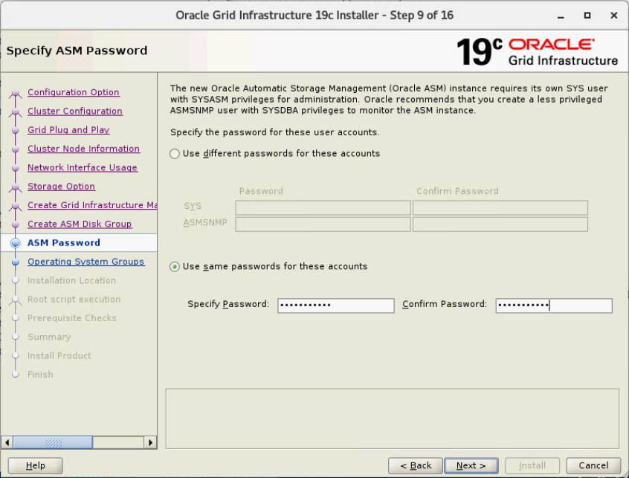

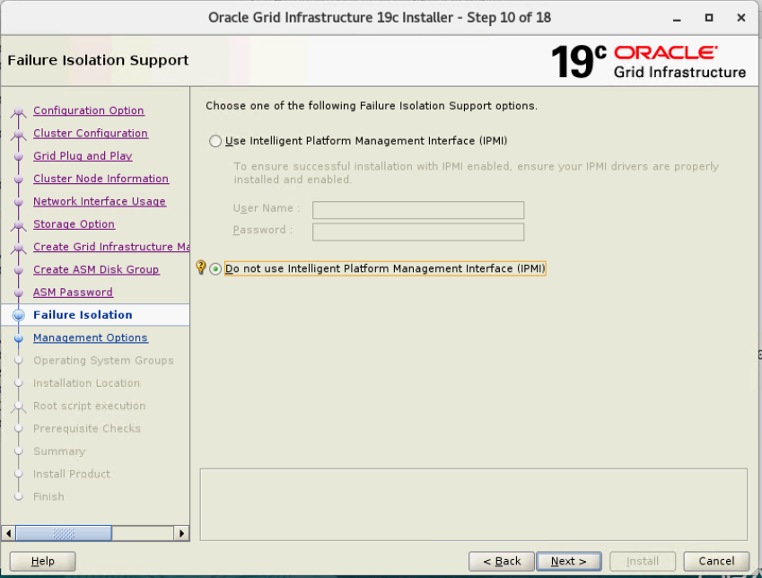

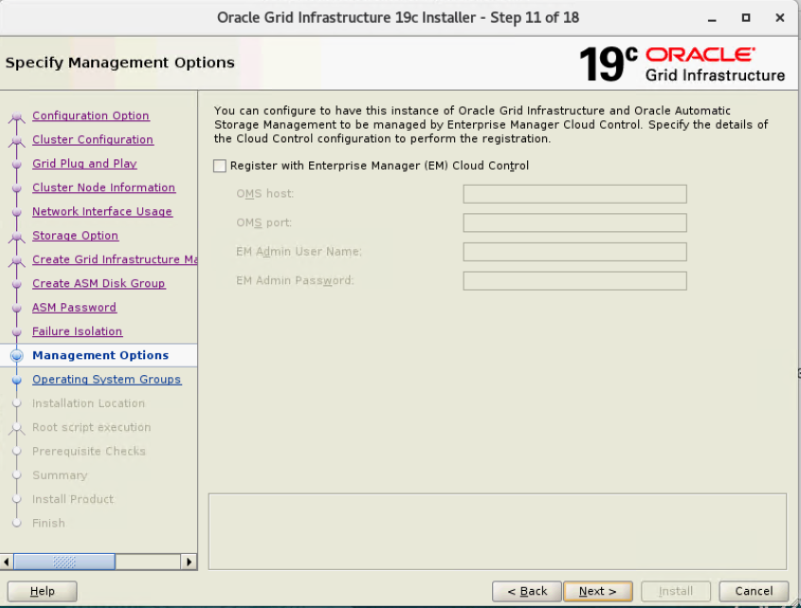

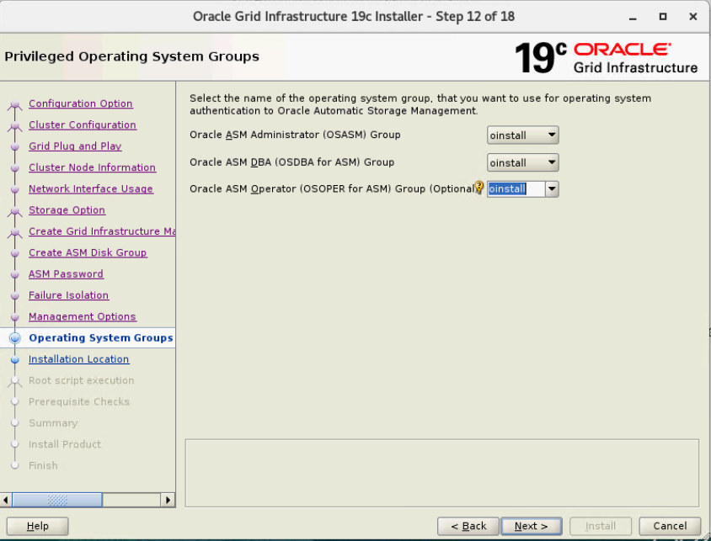

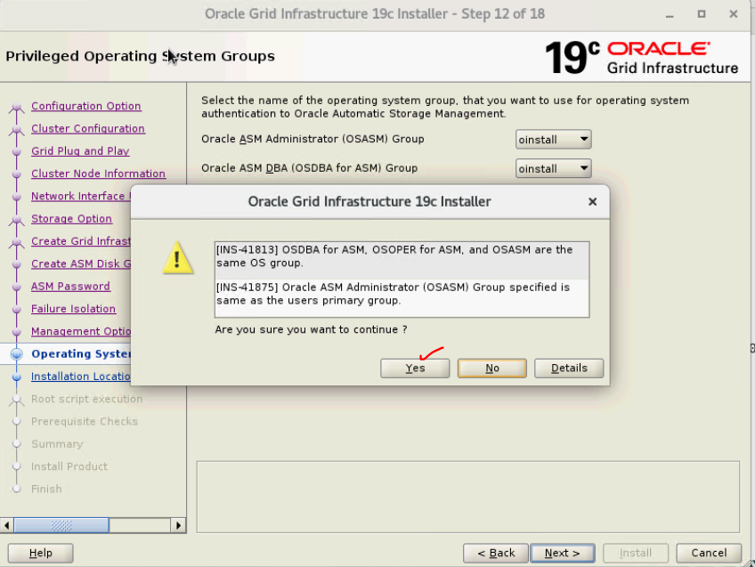

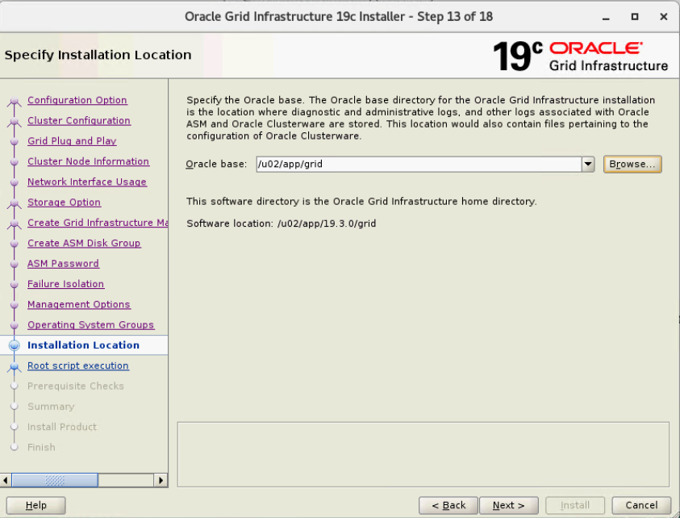

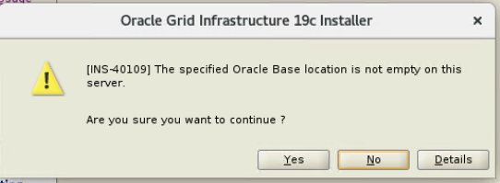

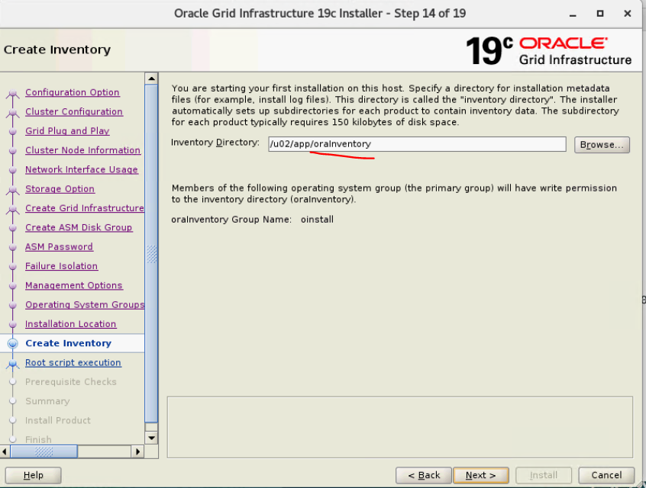

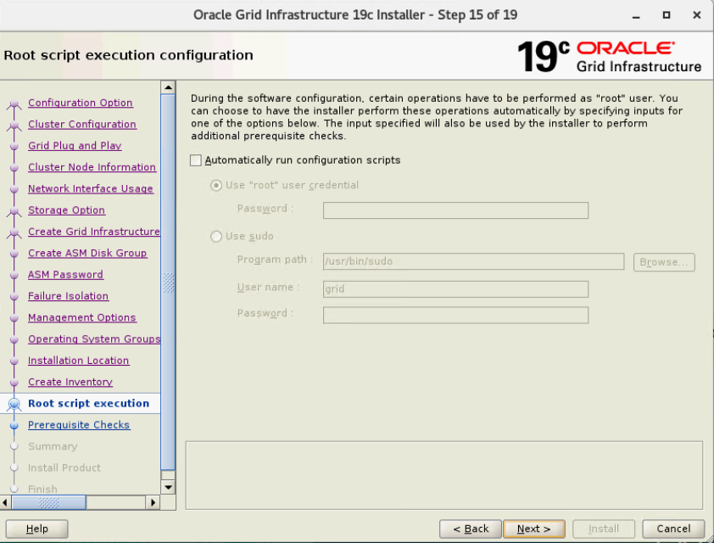

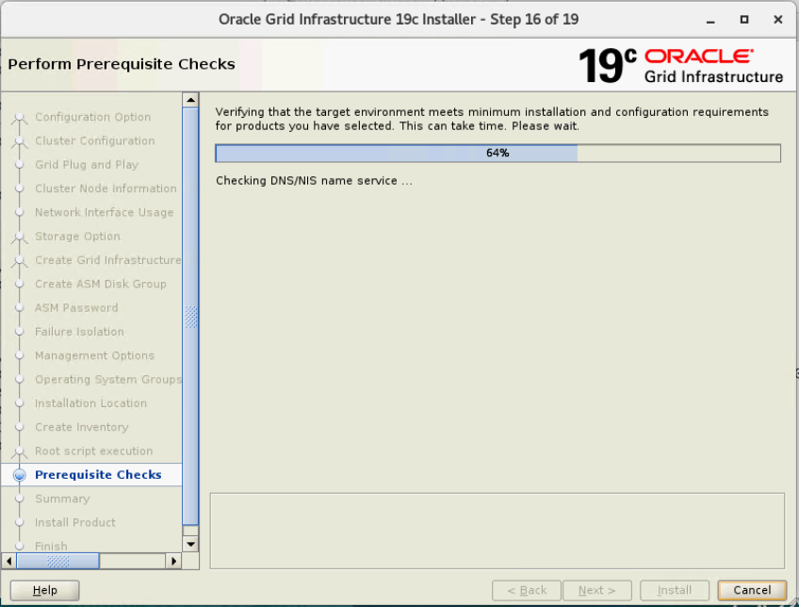

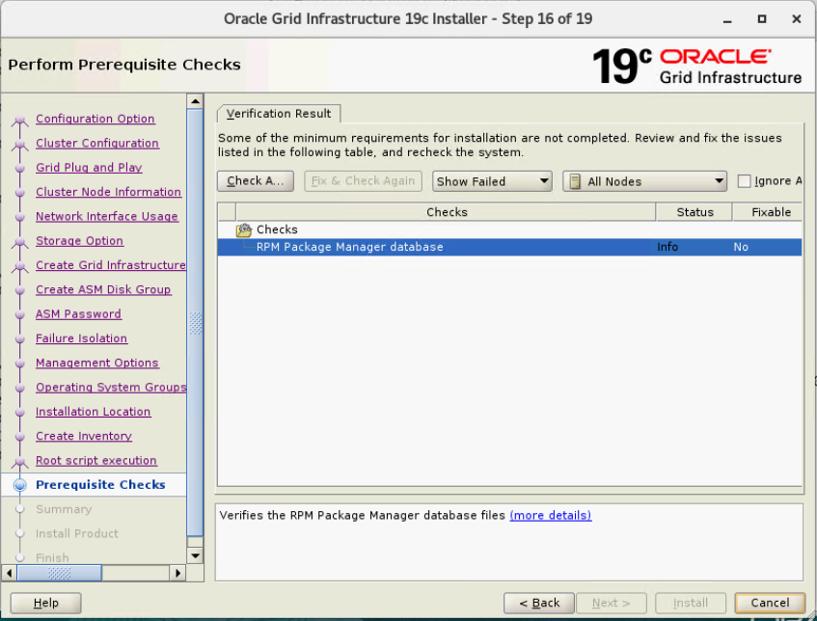

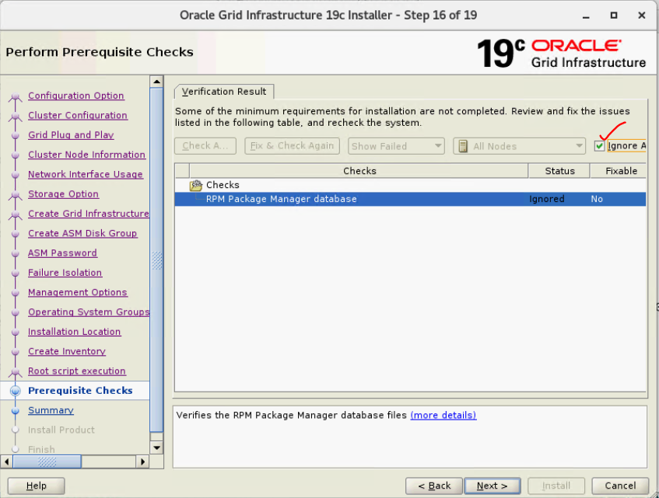

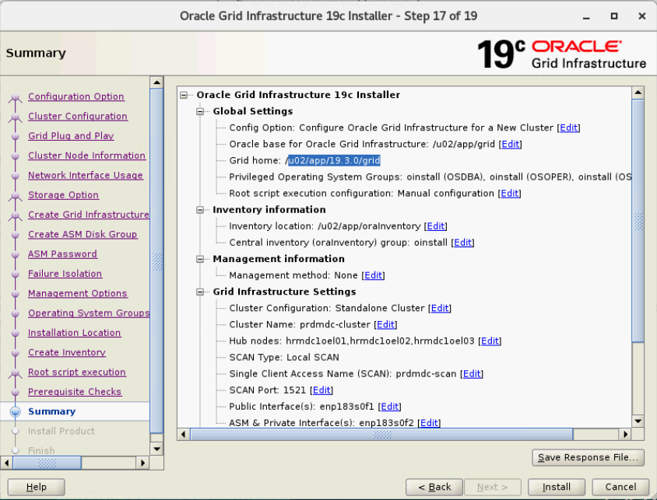

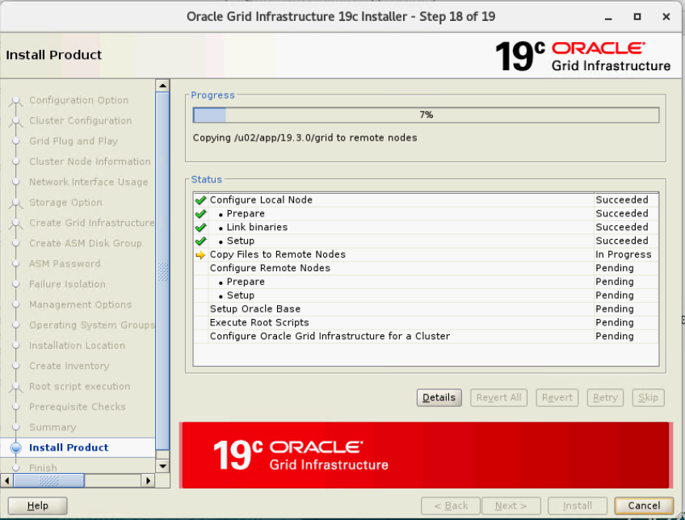

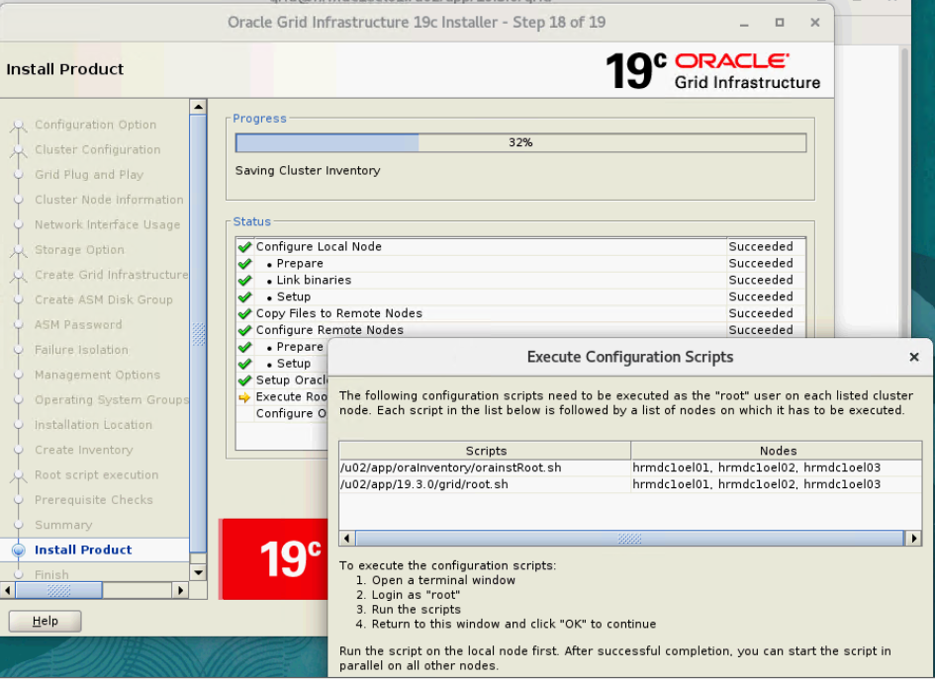

[root@hrmdc1oel01 ~]# /u02/app/oraInventory/orainstRoot.sh

Changing permissions of /u02/app/oraInventory.

Adding read,write permissions for group.

Removing read,write,execute permissions for world.

Changing groupname of /u02/app/oraInventory to oinstall.

The execution of the script is complete.

[root@hrmdc1oel01 ~]# ls -ltr /u02/app/19.3.0/grid/root.sh

-rwx------. 1 grid oinstall 405 Jul 26 13:17 /u02/app/19.3.0/grid/root.sh

[root@hrmdc1oel01 ~]# /u02/app/19.3.0/grid/root.sh

Performing root user operation.

The following environment variables are set as:

ORACLE_OWNER= grid

ORACLE_HOME= /u02/app/19.3.0/grid

Enter the full pathname of the local bin directory: [/usr/local/bin]:

Copying dbhome to /usr/local/bin ...

Copying oraenv to /usr/local/bin ...

Copying coraenv to /usr/local/bin ...

Creating /etc/oratab file...

Entries will be added to the /etc/oratab file as needed by

Database Configuration Assistant when a database is created

Finished running generic part of root script.

Now product-specific root actions will be performed.

Relinking oracle with rac_on option

Using configuration parameter file: /u02/app/19.3.0/grid/crs/install/crsconfig_params

The log of current session can be found at:

/u02/app/grid/crsdata/hrmdc1oel01/crsconfig/rootcrs_hrmdc1oel01_2023-07-26_01-24-41PM.log

2023/07/26 13:24:48 CLSRSC-594: Executing installation step 1 of 19: 'ValidateEnv'.

2023/07/26 13:24:48 CLSRSC-594: Executing installation step 2 of 19: 'CheckFirstNode'.

2023/07/26 13:24:49 CLSRSC-594: Executing installation step 3 of 19: 'GenSiteGUIDs'.

2023/07/26 13:24:50 CLSRSC-594: Executing installation step 4 of 19: 'SetupOSD'.

Redirecting to /bin/systemctl restart rsyslog.service

2023/07/26 13:24:50 CLSRSC-594: Executing installation step 5 of 19: 'CheckCRSConfig'.

2023/07/26 13:24:50 CLSRSC-594: Executing installation step 6 of 19: 'SetupLocalGPNP'.

2023/07/26 13:24:58 CLSRSC-594: Executing installation step 7 of 19: 'CreateRootCert'.

2023/07/26 13:25:02 CLSRSC-594: Executing installation step 8 of 19: 'ConfigOLR'.

2023/07/26 13:25:17 CLSRSC-594: Executing installation step 9 of 19: 'ConfigCHMOS'.

2023/07/26 13:25:17 CLSRSC-594: Executing installation step 10 of 19: 'CreateOHASD'.

2023/07/26 13:25:21 CLSRSC-594: Executing installation step 11 of 19: 'ConfigOHASD'.

2023/07/26 13:25:24 CLSRSC-330: Adding Clusterware entries to file 'oracle-ohasd.service'

2023/07/26 13:25:43 CLSRSC-594: Executing installation step 12 of 19: 'SetupTFA'.

2023/07/26 13:25:43 CLSRSC-594: Executing installation step 13 of 19: 'InstallAFD'.

2023/07/26 13:26:00 CLSRSC-594: Executing installation step 14 of 19: 'InstallACFS'.

2023/07/26 13:26:16 CLSRSC-594: Executing installation step 15 of 19: 'InstallKA'.

2023/07/26 13:26:20 CLSRSC-594: Executing installation step 16 of 19: 'InitConfig'.

[INFO] [DBT-30161] Disk label(s) created successfully. Check /u02/app/grid/cfgtoollogs/asmca/asmca-230726PM012651.log for deta

2023/07/26 13:27:31 CLSRSC-482: Running command: '/u02/app/19.3.0/grid/bin/ocrconfig -upgrade grid oinstall'

2023/07/26 13:27:41 CLSRSC-4002: Successfully installed Oracle Trace File Analyzer (TFA) Collector.

CRS-4256: Updating the profile

Successful addition of voting disk 29fc5c7553db4f42bf42fad9d9fc9f09.

Successfully replaced voting disk group with +OCRDG.

CRS-4256: Updating the profile

CRS-4266: Voting file(s) successfully replaced

## STATE File Universal Id File Name Disk group

-- ----- ----------------- --------- ---------

1. ONLINE 29fc5c7553db4f42bf42fad9d9fc9f09 (AFD:ASM_DISK_01) [OCRDG]

Located 1 voting disk(s).

2023/07/26 13:28:18 CLSRSC-594: Executing installation step 17 of 19: 'StartCluster'.

2023/07/26 13:29:21 CLSRSC-343: Successfully started Oracle Clusterware stack

2023/07/26 13:29:21 CLSRSC-594: Executing installation step 18 of 19: 'ConfigNode'.

2023/07/26 13:30:17 CLSRSC-594: Executing installation step 19 of 19: 'PostConfig'.

2023/07/26 13:30:32 CLSRSC-325: Configure Oracle Grid Infrastructure for a Cluster ... succeeded

[root@hrmdc1oel01 ~]#

[root@hrmdc1oel02 ~]# /u02/app/oraInventory/orainstRoot.sh

Changing permissions of /u02/app/oraInventory.

Adding read,write permissions for group.

Removing read,write,execute permissions for world.

Changing groupname of /u02/app/oraInventory to oinstall.

The execution of the script is complete.

[root@hrmdc1oel02 ~]# /u02/app/19.3.0/grid/root.sh

Performing root user operation.

The following environment variables are set as:

ORACLE_OWNER= grid

ORACLE_HOME= /u02/app/19.3.0/grid

Enter the full pathname of the local bin directory: [/usr/local/bin]:

Copying dbhome to /usr/local/bin ...

Copying oraenv to /usr/local/bin ...

Copying coraenv to /usr/local/bin ...

Creating /etc/oratab file...

Entries will be added to the /etc/oratab file as needed by

Database Configuration Assistant when a database is created

Finished running generic part of root script.

Now product-specific root actions will be performed.

Relinking oracle with rac_on option

Using configuration parameter file: /u02/app/19.3.0/grid/crs/install/crsconfig_params

The log of current session can be found at:

/u02/app/grid/crsdata/hrmdc1oel02/crsconfig/rootcrs_hrmdc1oel02_2023-07-26_01-31-53PM.log

2023/07/26 13:31:56 CLSRSC-594: Executing installation step 1 of 19: 'ValidateEnv'.

2023/07/26 13:31:56 CLSRSC-594: Executing installation step 2 of 19: 'CheckFirstNode'.

2023/07/26 13:31:57 CLSRSC-594: Executing installation step 3 of 19: 'GenSiteGUIDs'.

2023/07/26 13:31:57 CLSRSC-594: Executing installation step 4 of 19: 'SetupOSD'.

Redirecting to /bin/systemctl restart rsyslog.service

2023/07/26 13:31:57 CLSRSC-594: Executing installation step 5 of 19: 'CheckCRSConfig'.

2023/07/26 13:31:58 CLSRSC-594: Executing installation step 6 of 19: 'SetupLocalGPNP'.

2023/07/26 13:31:59 CLSRSC-594: Executing installation step 7 of 19: 'CreateRootCert'.

2023/07/26 13:31:59 CLSRSC-594: Executing installation step 8 of 19: 'ConfigOLR'.

2023/07/26 13:32:10 CLSRSC-594: Executing installation step 9 of 19: 'ConfigCHMOS'.

2023/07/26 13:32:10 CLSRSC-594: Executing installation step 10 of 19: 'CreateOHASD'.

2023/07/26 13:32:11 CLSRSC-594: Executing installation step 11 of 19: 'ConfigOHASD'.

2023/07/26 13:32:14 CLSRSC-330: Adding Clusterware entries to file 'oracle-ohasd.service'

2023/07/26 13:32:31 CLSRSC-594: Executing installation step 12 of 19: 'SetupTFA'.

2023/07/26 13:32:31 CLSRSC-594: Executing installation step 13 of 19: 'InstallAFD'.

2023/07/26 13:32:44 CLSRSC-594: Executing installation step 14 of 19: 'InstallACFS'.

2023/07/26 13:32:57 CLSRSC-594: Executing installation step 15 of 19: 'InstallKA'.

2023/07/26 13:32:58 CLSRSC-594: Executing installation step 16 of 19: 'InitConfig'.

2023/07/26 13:33:05 CLSRSC-594: Executing installation step 17 of 19: 'StartCluster'.

2023/07/26 13:33:54 CLSRSC-343: Successfully started Oracle Clusterware stack

2023/07/26 13:33:54 CLSRSC-594: Executing installation step 18 of 19: 'ConfigNode'.

2023/07/26 13:34:01 CLSRSC-594: Executing installation step 19 of 19: 'PostConfig'.

2023/07/26 13:34:07 CLSRSC-325: Configure Oracle Grid Infrastructure for a Cluster ... succeeded

Domain name to open is ASM/Self drc 4

[root@hrmdc1oel02 ~]#

[root@hrmdc1oel03 ~]# /u02/app/19.3.0/grid/root.sh

Performing root user operation.

The following environment variables are set as:

ORACLE_OWNER= grid

ORACLE_HOME= /u02/app/19.3.0/grid

Enter the full pathname of the local bin directory: [/usr/local/bin]:

Copying dbhome to /usr/local/bin ...

Copying oraenv to /usr/local/bin ...

Copying coraenv to /usr/local/bin ...

Creating /etc/oratab file...

Entries will be added to the /etc/oratab file as needed by

Database Configuration Assistant when a database is created

Finished running generic part of root script.

Now product-specific root actions will be performed.

Relinking oracle with rac_on option

Using configuration parameter file: /u02/app/19.3.0/grid/crs/install/crsconfig_params

The log of current session can be found at:

/u02/app/grid/crsdata/hrmdc1oel03/crsconfig/rootcrs_hrmdc1oel03_2023-07-26_01-37-09PM.log

2023/07/26 13:37:12 CLSRSC-594: Executing installation step 1 of 19: 'ValidateEnv'.

2023/07/26 13:37:12 CLSRSC-594: Executing installation step 2 of 19: 'CheckFirstNode'.

2023/07/26 13:37:13 CLSRSC-594: Executing installation step 3 of 19: 'GenSiteGUIDs'.

2023/07/26 13:37:13 CLSRSC-594: Executing installation step 4 of 19: 'SetupOSD'.

Redirecting to /bin/systemctl restart rsyslog.service

2023/07/26 13:37:13 CLSRSC-594: Executing installation step 5 of 19: 'CheckCRSConfig'.

2023/07/26 13:37:13 CLSRSC-594: Executing installation step 6 of 19: 'SetupLocalGPNP'.

2023/07/26 13:37:14 CLSRSC-594: Executing installation step 7 of 19: 'CreateRootCert'.

2023/07/26 13:37:14 CLSRSC-594: Executing installation step 8 of 19: 'ConfigOLR'.

2023/07/26 13:37:26 CLSRSC-594: Executing installation step 9 of 19: 'ConfigCHMOS'.

2023/07/26 13:37:26 CLSRSC-594: Executing installation step 10 of 19: 'CreateOHASD'.

2023/07/26 13:37:27 CLSRSC-594: Executing installation step 11 of 19: 'ConfigOHASD'.

2023/07/26 13:37:31 CLSRSC-330: Adding Clusterware entries to file 'oracle-ohasd.service'

2023/07/26 13:37:47 CLSRSC-594: Executing installation step 12 of 19: 'SetupTFA'.

2023/07/26 13:37:47 CLSRSC-594: Executing installation step 13 of 19: 'InstallAFD'.

2023/07/26 13:38:00 CLSRSC-594: Executing installation step 14 of 19: 'InstallACFS'.

2023/07/26 13:38:13 CLSRSC-594: Executing installation step 15 of 19: 'InstallKA'.

2023/07/26 13:38:14 CLSRSC-594: Executing installation step 16 of 19: 'InitConfig'.

2023/07/26 13:38:21 CLSRSC-594: Executing installation step 17 of 19: 'StartCluster'.

2023/07/26 13:39:07 CLSRSC-343: Successfully started Oracle Clusterware stack

2023/07/26 13:39:07 CLSRSC-594: Executing installation step 18 of 19: 'ConfigNode'.

2023/07/26 13:39:16 CLSRSC-594: Executing installation step 19 of 19: 'PostConfig'.

2023/07/26 13:39:22 CLSRSC-325: Configure Oracle Grid Infrastructure for a Cluster ... succeeded

Domain name to open is ASM/Self drc 4

[root@hrmdc1oel03 ~]#

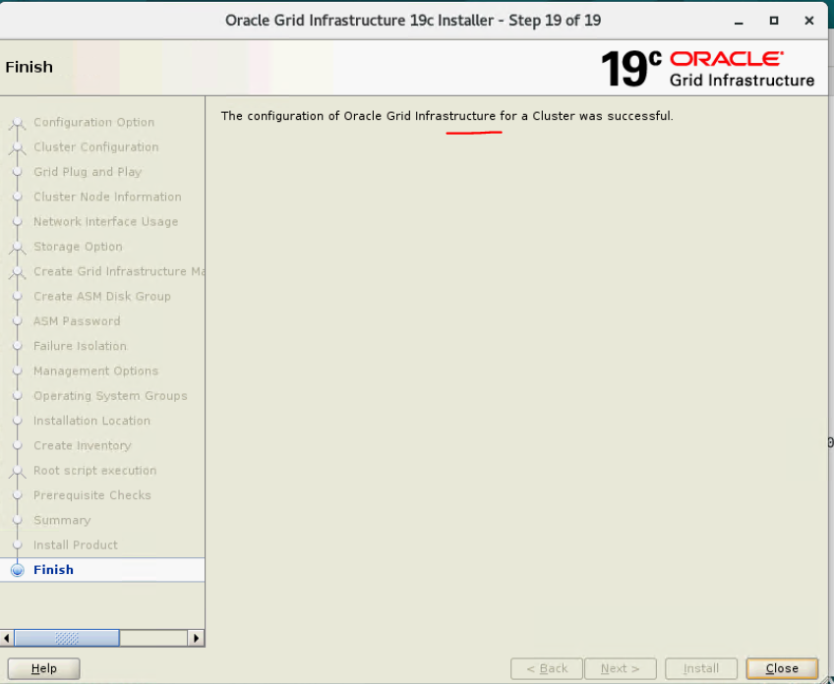

**============================================================== Install Oracle database Home.**

